MALAVIYA NATIONAL INSTITUTE OF TECHNOLOGY



## DEPARTMENT OF COMPUTER SCIENCE AND ENGINEERING

### COURSE: DATABASE MANAGEMENT SYSTEM

## COURSE CODE: CST305

#### PROJECT REPORT ON:

ONLINE RAILWAY RESERVATION SYSTEM

(WASTELAND TRACKS)

#### SUBMITTED TO:

#### DR. NAMITA MITTAL

#### SUBMITTED BY:

ROSHAN LAL(2015UCP1532)

**PAWAN KUMAR(2015UCP1622)** **MOHD. AQUIB ANSARI(2015UCP1686)**

## TABLE OF CONTENTS

1. Introduction
2. Proposed Solution
3. Entity Relationship Diagram
4. Web Design
5. Home Page
6. Registration Page
7. Login Page
8. User Page

* My Profile
* My Bookings
* PNR Enquiry
* Cancel Ticket
* Fresh Booking

1. Admin Page

* Add Station
* Add Train
* Manage Profile

1. Support Page
2. Developers Page

## INTRODUCTION:

This system is basically concerned with the reservation and cancellation of the railway tickets to the passenger. The need of this system arouse because it is known fact that India has the largest railway network in the whole world and it is not possible to handle such a large system manually. So, by computerizing it, it became possible to overcome the limitations and make the operations more efficient. The complexity in handling the data and records of such a vast system got reduced and became easier by computerizing the system.

More specifically, this online railway reservation system can perform the basic functions like reservation and cancellation. The users are required to register on the server for getting access to the database and query result retrieval. Upon registration completion, each user has an account which is essentially referred to as the ‘view level’ of the customer. The account contains comprehensive information of the user entered during the registration and allows the user to access their past reservations, enquire about train schedule, seat availability and make a fresh reservation. The user will also be able to update their account details, etc.

The master user of this system is the Railway Administrator(we three) who can login using his password and once a user is authenticated as the admin, he can access and modify information stored in the database of the system. This includes adding and updating trains, stations, train routes and also managing the user details.

## PROPOSED SOLUTION:

The railway network is a very vast system to be handled manually and its computerization will prove to be of great help to both the employees and the passengers. The

The customers are privileged with the following services:

* Register as customer by providing certain personal details and verification through OTP.
* View their profile and edit profile details, add money or change password.
* Make fresh reservations and book one or more (limited to 3 seats per tickets) seats.
* View past bookings and even do the cancellation of booked tickets.
* See trains between a pair of stations, check seat availability in trains and get the fare details.

Administrator is privileged with the following services:

* Login as the master user using his password.
* Add train, station & route, remove trains and update fares.
* See User Profiles.

The system’s security has been kept into consideration well. The database of the system cannot be accessed by any user either admin or customer without being authenticated by correct username and password. The password set can also be modified and in case if the user forgets the password, it can be recovered by giving a correct answer to a security question followed by an OTP verification .

This project has been designed in such a way so that it overcomes problems like data redundancy.

## ENTITY RELATIONSHIP DIAGRAM:

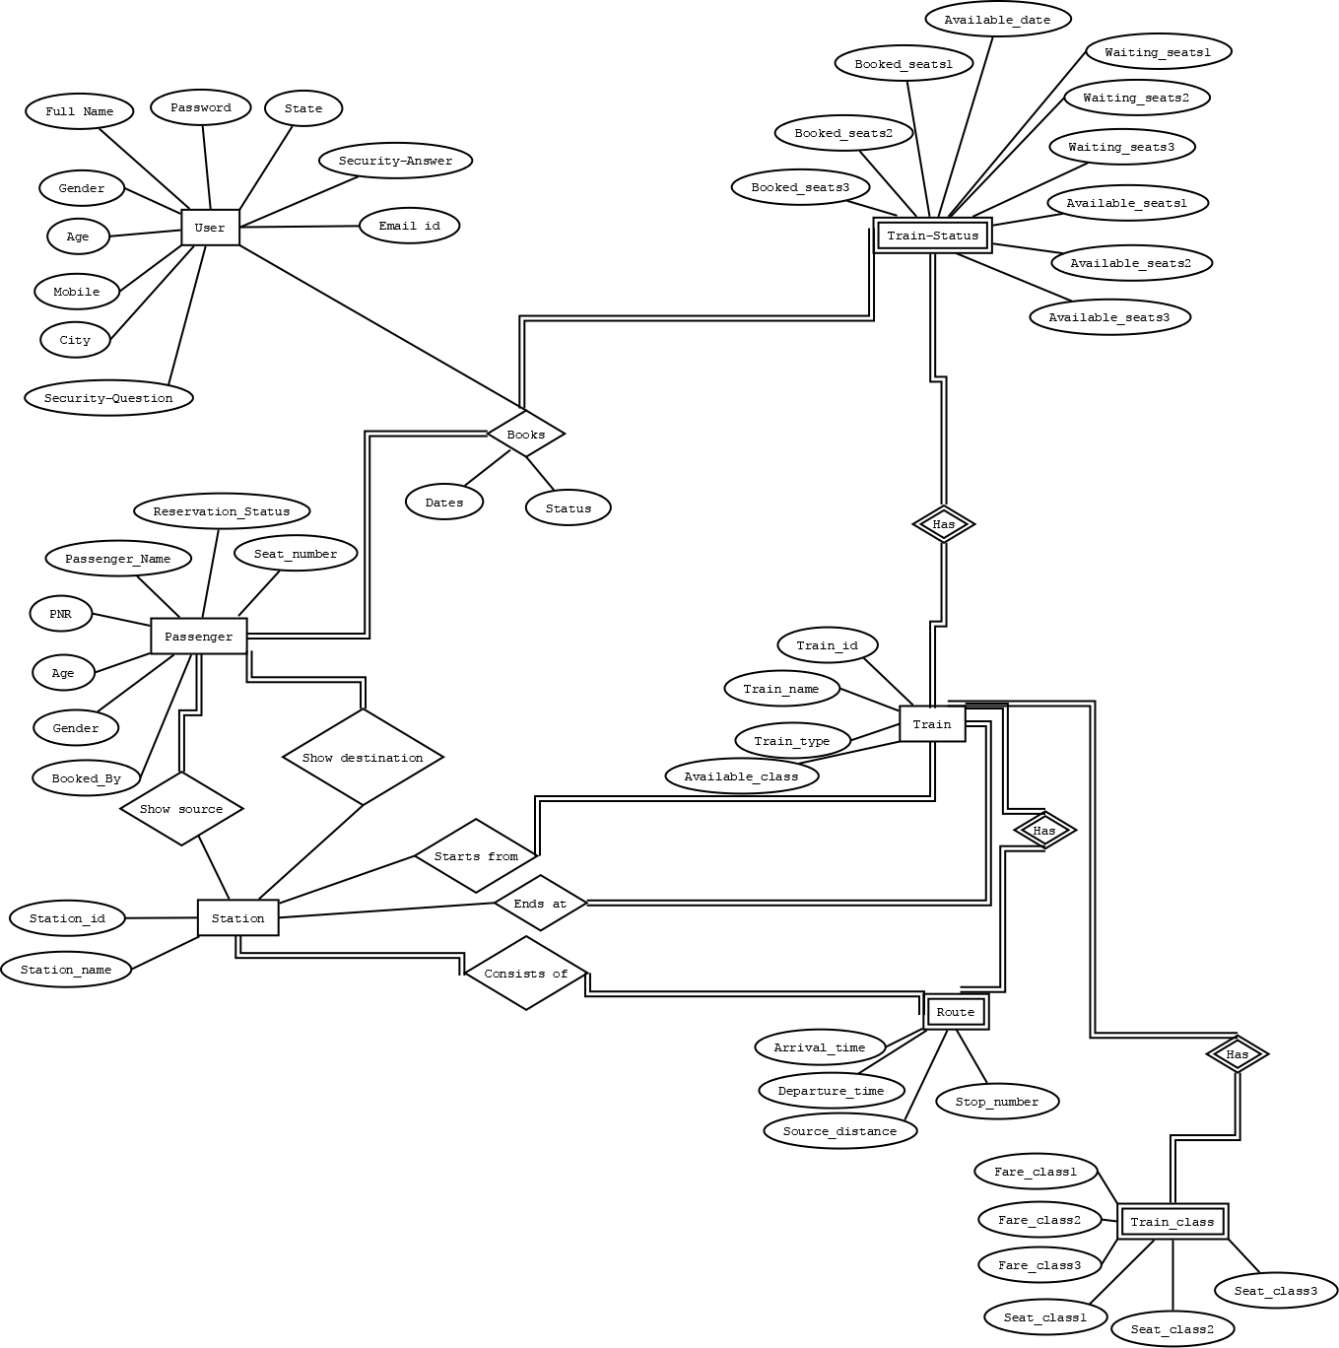

## WEB DESIGN:

|  |
| --- |
| 1. HOME PAGE |
|  |
| DESCRIPTION: The home page contains a navigation bar at the top which can take you everywhere on the website, a footer containing copyrights details and external links to connect WASTELAND TRACKS on social media. |

|  |
| --- |
| 1. REGISTRATION PAGE |
|  |
| DESCRIPTION: Every new user has to go through a registration process, which requires user to provide the required details and agreement of all the terms and conditions which can be downloaded from the very page. The user must verify his mail-id through a OTP. |

|  |
| --- |
| 1. LOGIN PAGE |
|  |
| DESCRIPTION: Existing users and Admin can log into their accounts using their respective mail-id and passkey. If the user forgets his password, he can change it by clicking Forgot Password where he will be asked the security question and answer submitted at the time of registration followed by an OTP verification. |

|  |
| --- |
| 4) USER PAGE |
|  |
| DESCRIPTION: Upon successful login, user will be ridirected to a page like this, where he/she can see his/her profile, book a fress ticket, see his past bookings, enquire upon a PNR and cancel ticket. |
| 5) USER PROFILE |
|  |
| DESCRIPTION: My profile will take the user to this page where he/she can change his/her picture, Add Money in wallet, edit his/her profile and change password. Adding money to Wasteland’s Wallet requires that the user have less than 5000(INR). One can not add more than 20,000(INR) at a time. |

|  |
| --- |
| 6) PAST BOOKINGS |
|  |
| DESCRIPTION: All the past made bookings can be retrieved from here. One can print the tickets if he want. |

|  |
| --- |
| 7) PNR ENQUIRY |
|  |
| DESCRIPTION: Users who have reserved seats in any of the trains can enter the PNR number provided to them and can see the status of their ticket and print them. |

|  |
| --- |
| 8) CANCEL TICKET |
|  |
| DESCRIPTION: User can cancel his/her booked ticket by entering PNR number. In case of cancellation a nominal amount will be deducted from total fare and rest amount will be refunded to user’s wasteland wallet. |

|  |
| --- |
| 9) NEW BOOKING |
|  |
|  |
| DESCRIPITON: User can book a fresh ticket by entering source, destination and journey date, which will direct them to a list of trains along with their seat availabilty as shown below. |

|  |
| --- |
| 10) TRAINS LIST |
|  |
| DESCRIPTION: User have to choose a class for his journey. After that he will be redirected to a page asking for passenger details as shown below. |
| 11) PASSENGERS & PAYMENT DETAILS |
|  |
| DESCRIPTION: On successful submission of this form, one will get the |

|  |
| --- |
| 12) ADMIN PAGE |
|  |
| DESCRIPTION: Upon successful login, admin will be ridirected to a page like this, where he can add trains, remove trains, add stations, update fares and see user profiles. |

|  |
| --- |
| 13) ADD STATION |
|  |
| DESCRIPTION: The admin is privileged to add and update new stations and station ID to the system database. |

|  |
| --- |
| 14) ADD TRAIN |
|  |
| DESCRIPTION: Admin can add new trains to the database which will be further allowed for reservations. Train will be assigned a Train-number which should be unique and then a train name will be assigned to the train for its identification and other information. |

|  |
| --- |
| 15) MANAGE USER PROFILES |
|  |
| DESCRIPTION: Admin can view the details of registered users. |
| 16) SUPPORT |
|  |
| DESCRIPTION: This page is for assistance. One can raise his/her issue on social media or leave a message. |

|  |
| --- |
| 17) DEVELOPERS |
|  |
| DESCRIPTION: This page gives the info about the developers. If one wants to connect with them on social media, link are provided. |

Thank You !